- Open an Excel sheet with a list of song names and artists (at least 20 rows, with some duplicate song names), and use Conditional Formatting to highlight all duplicate song names in yellow.
ANSWERS:
Song_Name | Artist
Kesariya | Arijit Singh
Tum Hi Ho | Arijit Singh
Apna Bana Le | Arijit Singh
Kesariya | Pritam
Deva Deva | Arijit Singh
Raataan Lambiyan | Tanishk Bagchi
Pasoori | Ali Sethi
Tum Hi Ho | Mithoon
Calma | Pedro Capó
Shape of You | Ed Sheeran
Blinding Lights | The Weeknd
Pasoori | Shae Gill
Starboy | The Weeknd
Stay | The Kid LAROI
Bad Habits | Ed Sheeran
As It Was | Harry Styles
Deva Deva | Jonita Gandhi

- Given a table of Flipkart product prices, apply a Color Scale conditional formatting rule so that the highest prices show in dark green, the lowest in red, and the rest in gradient colors.
ANSWERS:
Product_Name | Price
Apple iPhone 15 | 65999
Samsung Galaxy S24 | 74999
Sony WH-1000XM5 | 29990
Dell XPS 13 | 115000
Apple iPad Air | 59900
HP Pavilion 15 | 52990
Boat Airdopes 141 | 1299
Kindle Paperwhite | 14999
JBL Flip 6 | 9999
Logitech MX Master 3S | 8995

- Create a list of your last 15 Zomato orders with their ratings (1-5 stars) in Excel, and use Icon Sets (traffic lights) to visually indicate: green for ratings 4 and above, yellow for 3, red for below 3.
Hint: Choose the 'Traffic Lights' icon set and set custom rules for each icon based on the rating values.
ANSWERS:
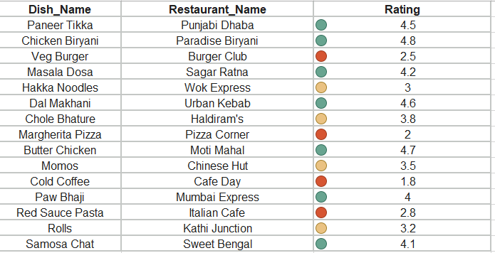

- In an Excel sheet of IPL players and their total runs, use Conditional Formatting to highlight the top 3 run-scorers in blue and the bottom 3 in orange.
ANSWERS:
Player_Name | Total_Runs
Virat Kohli | 8004
Shikhar Dhawan | 6769
Rohit Sharma | 6628
David Warner | 6563
Suresh Raina | 5528
MS Dhoni | 5243
AB de Villiers | 5162
Chris Gayle | 4965
Robin Uthappa | 4952
Dinesh Karthik | 4842
KL Rahul | 4683
Sanju Samson | 4419

- Take an Excel table of monthly expenses and targets (e.g., for Swiggy, Myntra, Paytm, etc.), and set up a conditional formatting rule that colors the expense cell green if it is under the target, and red if it is over the target.
Constraint: Do not use the same color-coding logic as the trainer's revenue demo—apply it to expenses vs. targets instead.
ANSWERS:
Platform | Target_Budget | Actual_Expense
Swiggy | 5000 | 4200
Myntra | 3000 | 3800
Paytm | 2000 | 1500
Uber | 4000 | 4500
Zomato | 3500 | 3100
Amazon | 6000 | 6200
Blinkit | 2500 | 2100
BookMyShow | 1500 | 1800

